Design, Simulate, Build and Test a Boost DC-DC Converter for Use in Robotics and Autonomous Devices.
LTC1871-Based 12 V / 2 A Converter for Battery-Powered Mobile Platforms

Fortune Olose

Final Year Project
B.E. Electronic and Computer Engineering



A thesis submitted in partial fulfilment of the requirements for the Maynooth University B.E. in Electronic Engineering

May 2026

Supervisor: Dr. Bob Lawlor.

Abstract
This report demonstrates the design, simulation, and printed circuit board layout of a DC-DC boost converter for a battery-powered mobile robotic platform. The converter accepts a three-cell lithium polymer battery input range of 8V to 11V and regulates a stable 12V output at up to 2A continuous load current, supplying power to a single board computer, a laser scanner, and a long-range radio modem. The project follows a two-phase methodology. Phase 1 develops the complete power stage analytically from first principles, including inductor sizing, output capacitor bank design with ceramic capacitor bank design with ceramic capacitor DC bias derating, feedback network, and Type II compensation shaped by right-half-plane zero constraints. An iterative topology development is documented: an initial SEPIC concept and a TPS61088 integrated converter were each abandoned due to simulation convergence failures, leading to the final LTC1871 current mode controller following supervisor consultation. Phase 2 validates the design through a comprehensive LTSpice simulation campaign, confirming output voltage regulation to within 0.16% of the analytical predictions, line regulation of 2.9 microvolts per volt, load transient recovery in 2.18 microseconds under a 1.5 A step, and efficiency of 94.83% at full load. All eight-performance metrics satisfy their design specifications with substantial margin. A two-layer printed circuit board was designed in KiCAD and verified through design rule checking.

Declaration
I declare that this thesis and the project it describes are exclusively my own work, except where specifically noted. I confirm that I have appropriately cited all information derived from the published and unpublished work of others.

Table of Contents
Abstract ii
Declaration ii
1 Introduction 1
1.1 Original Contributions and Externally Provided Resources 1
1.2 Structure of report 1
2 Technical Background 1
3 Body of the work 1
4 Conclusions and future work 3
Glossary of terms [OPTIONAL] 3
Nomenclature [OPTIONAL] 3
References 3
Appendix A [OPTIONAL] 3

Introduction
Introduce the topic that is addressed by this project. Please refer to the handbook for content guidelines.

Original Contributions and Externally Provided Resources
Briefly describe your main achievements or contributions in the project (normally 3-5 of these). Clearly identify resources or contributions to the project that are not your own work. See handbook for details.

Structure of report
Briefly outline the content in each of the remaining chapters of your report, using no more than a line or two for each section. A bulleted list may be useful here.

Technical Background
The purpose of this chapter is to provide the reader with all of the important/significant background material. Please refer to the handbook for content guidelines.

Body of the work
The main work of your project may be reported as one chapter (divided into subsections as needed) or several top-level chapters might be appropriate depending on the project and work items conducted. Please refer to the handbook for content guidelines.
If you need to use figures, they should be captioned and centred. It is not necessary to align them to the top or bottom of the page. You can use the paragraph style “figure” to format a figure in the main body of the text correctly. To correctly write a figure caption (so that it can be cross referenced in the text), right-click the figure and choose “insert caption”.
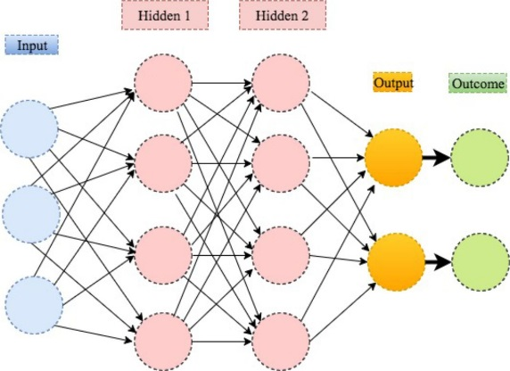
Figure 1 The caption should briefly explain the figure. If the figure is copied from somewhere (copyright permitting), cite the original source.
Generally, equations should be centred on a line. If the equation must be referenced elsewhere in the document, it must include an equation number aligned to the right of the column. To avoid issues with Microsoft Word’s less than perfect interface for doing this, copy and paste the following table and then edit or replace the math whenever you need a new centred and numbered equation. (You may need to select the equation number and click F9 for it to update after pasting. If you cannot see the table gridlines for used to lay out the following equation, then click beside the equation and go to Table Tools > Layout > View Gridlines from the menu.)
 | $$A=πr^{2}$$ | (1)
 | $$f\left(x\right)=a_{0}+\sum_{n=1}^{∞}{\left(a_{n}\cos{\frac{nπx}{L}}+b_{n}\sin{\frac{nπx}{L}}\right)}$$ | (2)

To cross reference equations formatted as above, go to references > cross reference > equations, e.g. see (1).
Tables are normally formatted so that they are centred and the table caption goes above the table (select the table, right click, insert caption). Further explanatory notes (if needed) usually follow the table. To cross reference the table go to references, cross reference, tables, for example see Table 1 (next page).

Table 1 The caption should briefly explain what the table shows, e.g. precision results of the classifiers under test for different feature subsets. If the data comes from elsewhere, cite the source. If column titles, units, or values need more explanation than can fit in the column, add notes below the table.
Classifier | Precision
 | Text- specific (1) | N-grams (2) | Post-specific (3) | 1 & 2 | 1 & 3 | All
Perceptron | 0.78 | 0.82 | 0.24 | 0.81 | 0.77 | 0.83
Decision tree | 0.65 | 0.79 | 0.56 | 0.75 | 0.65 | 0.73
One class SVM | 0.54 | 0.51 | 0.52 | 0.53 | 0.54 | 0.53
1 & 2 is the combination of text-specific features and n-grams.
1 & 3 is the combination of text-specific and post-specific features

Conclusions and future work
Identify and discuss the main implications of your work. Please refer to the handbook for further content guidelines for this section.

Glossary of terms [OPTIONAL]
Your report may not require a glossary of terms, but if it does, place it here.

Nomenclature [OPTIONAL]
Your report may not require a nomenclature section. Normally this is only required if there is extensive use of mathematics throughout the report and the symbols or nomenclature are not obvious. If nomenclature is needed, place it here.

References
List all your references here using a standard consistent style. See handbook for detailed guidelines.

Appendix A [OPTIONAL]
Appendices are optional and may not be required by your project. If you do require appendices, place them here.

Risk Assessment
Include your unsigned risk assessment form here, i.e. no signatures. This is the electronic version of risk assessment form before it was signed by you or the safety officers. The content should match the most recently signed off version except that, for GDPR and future sharing of the report, there are no signatures and no student numbers included.

